SAMR Examples: Questions and Transitions
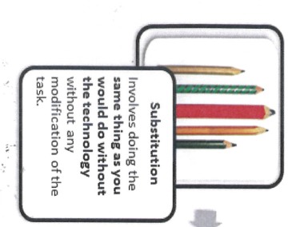 | 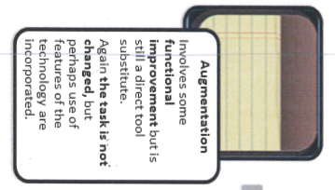 | 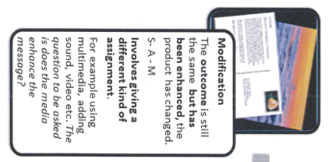 | 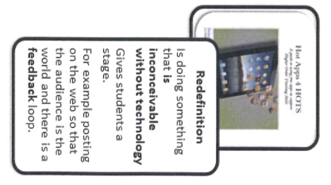
Substitution  S  Involves doing the same thing as you would do without the technology without any modification of the task. | Augmentation  S-A  Involves some functional improvement but is still a direct tool substitute. Again, the task is not changed, but perhaps use of features of the technology is incorporated. | Modification  S-A-M  The outcomes is still the same but has been enhanced, the product changed. Involves giving a different kind of assignment. For example using multimedia, adding sound, video, etc. The question to be asked is does, the media enhance the message? | Redefinition  S-A-M-R  Is doing something that is inconceivable without technology. Gives students a stage. For example, posting on the web so that the audience is the world and there is a feedback loop.
QUESTIONS and TRANSITIONS:
- What will I gain by replacing the older technology with the new technology? | - Have I added an improvement to the task process that could not be accomplished with the older technology at a fundamental level?  - How does this feature contribute to my design? | - How is the original task being modified?  - Does this modification fundamentally depend upon the new technology?  - How does this modification contribute to my design? | - What is the new task?  - Will any portion of the original task be retained?  - How is the new task uniquely made possible by the new technology?  - How does it contribute to my design?

